 | 12.1.47 Editors - Geometry Nodes Editor - Header - Add Menu - Hair - Utility
Table of content
Detailed table of content 1
Add menu - Hair - Utility 2
Attach Hair Curves to Surface 2
Redistribute Curve Points 3
Restore Curve Segment Length 4

Detailed table of content
Detailed table of content
Detailed table of content 1
Add menu - Hair - Utility 2
Attach Hair Curves to Surface 2
Input 2
Geometry 2
Surface Object 2
Surface 2
Surface UV Map 2
Surface Rest Position 2
Sample Attachment UV 2
Snap to Surface 3
Align to Surface Normal 3
Blend along Curve 3
Output 3
Geometry 3
Surface UV Coordinate 3
Surface Normal 3
Redistribute Curve Points 3
Input 3
Curves 3
Factor 3
Feature Awareness 3
Output 3
Curves 3
Restore Curve Segment Length 4
Input 4
Curves 4
Selection 4
Factor 4
Reference Position 4
Pin at Parameter 4
Output 4
Curves 4

Add menu - Hair - Utility
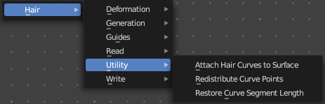
Hair nodes are, different from the other nodes in the add menu, groups of nodes. And not single nodes. You can enter the node tree by clicking at the icon up right. Tab to leave the node tree. And you can of course also edit the node tree.




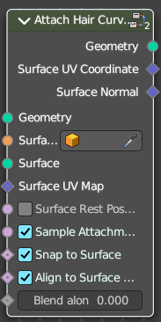
Attach Hair Curves to Surface
Attaches hair curves to a surface mesh.

Input

Geometry
The input geometry.

Surface Object
A surface object to attach to. It needs to have matching transforms.

Surface
Surface geometry to attach hair curves to.

Surface UV Map
Surface UV Map used to attach hairs to.

Surface Rest Position
Set the surface into rest position before attachment.

Sample Attachment UV
Sample the surface UV mapp at the attachment point.

Snap to Surface
Snap the root of the curve to the closest surface point.

Align to Surface Normal
Align the curves to surface normals. Needs a guide as reference.

Blend along Curve
Blend deformation along eacah curve from the root.

Output

Geometry
The output geometry.

Surface UV Coordinate
Surface UV Coordinate at the attachment point.

Surface Normal
Surface Normal at the attachment point.

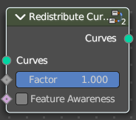
Redistribute Curve Points
Redistributes existing control points evenly along each curve.

Input

Curves
The input curve.

Factor
Factor to blend overall effect.

Feature Awareness
Use simple feature awareness to keep feature definition.

Output

Curves
The output curves.

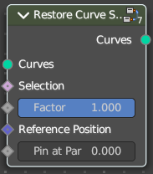
Restore Curve Segment Length

Input

Curves
The input curve.

Selection
A selection of the input curve.

Factor
Factor to blend overall effect.

Reference Position
Reference position before deformation.

Pin at Parameter
Pin each curve at a certain point for the operation.

Output

Curves
The output curves.

